


Korea Lunar Exploration Program
DTNPL Software Test Plan & Procedures

Date: 28 Dec. 2017 | Doc. No: KPLO-D0-550-202  Issue: 1.0  Total page: 25

Superseding Revised

Prepared By:  Hyun-Woong Choi Date  DTN SBC S/W Engineer, Lumir  Dae-Soo Oh Date  DTN SBC Engineer, Lumir |  | Kyung-Rak Lee Date  DTN Payload Engineer, ETRI
Reviewed By:  Jin-Ho Jo Date  DTN System Engineer, ETRI |  | Sin-Ae Ji Date  Proximity-1 System Engineer, ETRI
Sang-Man Moon Date  RLE KPLO Electrical System, KARI |  | Hyun-Jin Shin Date  RLE KPLO Mechanical System, KARI
Approval Signature:  Byoung-Sun Lee Date  DTN Project Leader, ETRI |  | Il-Young Kim Date  RLE KPLO Product Assurance, KARI
Seong-Bin Lim Date  Head, Lunar Exploration System Team, KARI |  | Seok-Weon Choi Date  Director, Lunar Exploration Program Office, KARI

Original CDMO Release__________________

Revision History
Version | Author(s) |  | Date | Description
0.1 | Hyun-Woong Choi |  | 2017. 12. 28 | Draft

Revision/Change Records
Version | Date | Revision/Change Description | Pages
0.1 | 2017. 12. 28 | Initial | All

Documents Tree

Contents

1. Introduction 8
1.1. Purpose and Scope 8
1.2. Applicable Documents 8
1.2.1. ETRI Documents 8
1.2.2. Other Documents 8
1.3. Abbreviations 8
2. Overview of KPLO DTN 10
2.1. DTN and Space Communications 10
2.2. Mission of DTN Operation 10
2.3. DTN Configurations 10
2.4. Communication Nodes 11
2.4.1. DTN nodes 11
2.4.2. Non-DTN nodes 11
3. Software Test Plan 12
3.1. Test Target 12
3.1.1. ION 12
3.1.2. DTNPL Management 12
3.1.3. SCH 12
3.1.4. DMA_UART 12
3.1.5. USRT 13
3.2. Approach 14
3.3. Pass/Fail Criteria 14
3.3.1. TC Verification 14
3.3.2. Functional Test 14
4. Software Test Procedure 15
4.1. Test Setting 15
4.2. Test Steps 15
4.2.1. Power supply 15
4.2.3. DTNPL EGSE PC Set Up 16
4.2.4. Telecommand Test 19
4.2.5. Telemetry Test 23

Figures

Figure 2.1 DTN test configuration in the first phase 11
Figure 3.1 DTNPL Software Layer 12
Figure 3.2 DTNPL Software Archetecture 12
Figure 3.3 DTNPL Test Configuration 14
Figure 4.1 run time test result 15
Figure 4.2 DTNPL EGSE GUI 16
Figure 4.3 Command and Telemetry Server Window 17
Figure 4.4 Command Sender Window 17
Figure 4.5 Packet Viewer Window 18
Figure 4.6 Command and Telemetry Server Window 18
Figure 4.7 TC DDC DATA 19
Figure 4.8 TC ECHO TEST 19
Figure 4.9 TC SW INITIALIZE 20
Figure 4.10 TC ION START 20
Figure 4.11 TC ION STOP 20
Figure 4.12 TC SOH REQUEST 21
Figure 4.13 TC TIME SETTING 21
Figure 4.14 SOH Telemetry 23

Tables

Table 4-1 DTNPL Test Configuration 15
Table 4-1 DTNPL Command Data Structure 22
Table 4-2 DTNPL Command Data Structure 22
Table 4-2 DTNPL Telemetry Lists 24

Introduction

Purpose and Scope
This document defines the electrical and mechanical interfaces between KPLO bus and DTN payload.

Applicable Documents

ETRI Documents
Document Number | Document Title
KPLO-D0-550-000 | System Requirement of DTN Payload
KPLO-D0-550-001 | System Specification of DTN Payload

Other Documents
Document Number | Document Title
KPLO-SP-310-001 | KPLO System Specification Document
KPLO-SP-340-001 | KPLO Payload/Spacecraft Bus ICD

Abbreviations
AMS | Asynchronous Message Service
BP | Bundle Protocol
BSS | Bundle Streaming Service
CCSDS | Consultative Committee for Space Data Systems
CFDP | CCSDS File Delivery Protocol
DCC | DTN Control Center
CRC | Cyclical Redundancy Check
DMA | Direct Memory Access
DTN | Delay(Disruption) Tolerant Network
DTNPL | DTN Payload
EOD | End of Data
EOF | End of File
FW | Firm Ware
FSW | Flight Software
ION | Interplanetary Overlay Network
KDSA | Korea Deep Space Antenna
KPLO | Korea Pathfinder Lunar Orbiter
LCM | Lander Communication Model
LTP | Licklider Transmission Protocol
MOC | Mission Operation Center
OBC | On Board Computer
OBT | On Board Time
PDHU | Payload Data Handling Unit
RCM | Rover Communication Model
RFU | Reserved for Future Use
SBC | Single Board Computer
SOD | Start of Data
SOF | Start of File
SOH | Start of Head
TBC | To Be Confirmed
TBD | To Be Defined
TC | Tele-command
TCP | Transmission Control Protocol
TM | Telemetry
UART | Universal Asynchronous Receiver Transmitter
USRT | Universal Synchronous Receiver Transmitter

Overview of KPLO DTN

DTN and Space Communications
Delay/disruption tolerant networking (DTN) technology offers a new solution to highly stressed communications in space environments, especially those with long link delay and frequent link disruptions in deep space missions. Delay/disruption tolerant networking (DTN) technology offers a new solution that use a store-and-forward mechanism to combat long link delay and frequent link disruptions generally characterizing space communications. DTN communications use a bundle protocol (BP), to construct a store-and-forward overlay network. The BP, situated at the application layer of the Internet model, utilizes conventional Internet protocols to send and receive data bundles. The benefits of DTN communications are as follows.
- Interoperability and Reuse: A standardized DTN protocol suite enables interoperability of multi-agency communication assets and also allows NASA to use the same communication stack for future missions (LEO, NEO or Deep Space).
- Space Link Efficiency, Utilization and Robustness: DTN enables more reliable and efficient data transmissions resulting in more usable bandwidth. DTN also improves link reliability by having multiple network paths and assets for potential communication hops.
- Security: The DTN Bundle Security Protocol (BSP) allows for integrity checks, authentication and encryption, even on links where not previously used.
- Quality of Service: The DTN protocol suite allows for many priority levels to be set for different data types, ensuring that the most important data is received ahead of less important data.
- Improved Operations and Situational Awareness: The DTN store-and-forward mechanism along with automatic retransmission provides more insight into events during communication outages and significantly reduces the need for ground-based scheduling.

Mission of DTN Operation
The mission of DTN is to validate DTN communication protocols by space link testing through KPLO. So DTN operations are focused on testing the DTN protocols using KPLO space links.

DTN Configurations
In the first phase of lunar exploration, test lunar orbiter called Korea Pathfinder Lunar Orbiter (KPLO) will be launched without lunar lander. Figure 2.1 shows DTN configuration in first phase of lunar exploration. There are no Lander and Rover on the moon in first phase. So Lander Communication Model (LCM) and Rover Communication Model (RCM) will be located on earth for the DTN communication testing.
DTN Payload (DTNPL) is a DTN node in the space. DTNPL will be mounted on the KPLO for DTN communication. DTN Control Center (DCC) is a control center of DTN communication nodes. LCM and RCM are DTN nodes on ground. All DTN nodes on ground are interconnected by the terrestrial network such as Internet. Mission Operation Center (MOC) and Korea Deep Space Antenna (KDSA) are not DTN nodes. They just transfer DTN packets to next communication nodes.

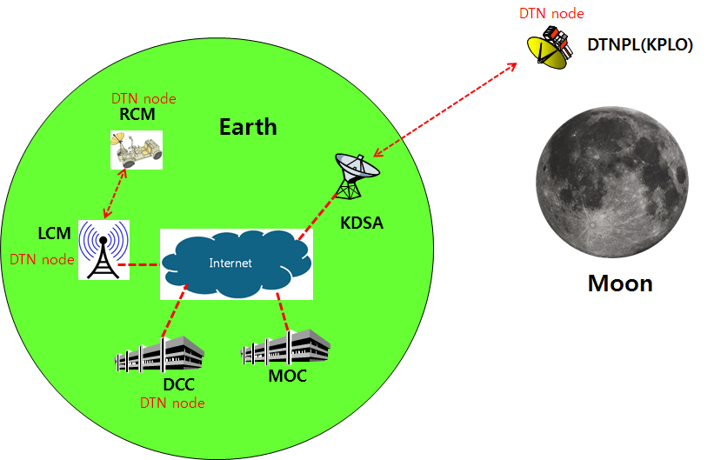
Figure 2.1 DTN test configuration in the first phase

Communication Nodes
Many communication nodes are needed for the DTN operation. Some of communication nodes in the network are DTN nodes whereas otherwise nodes are non-DTN nodes. The function of communication nodes used in the DTN operation is as follows.

DTN nodes
- DCC is a ground DTN node which monitor and controls DTN nodes. DCC send commands to DTN nodes such as DTNPL, LCM and RCM. It also receives telemetries or acquired data from some DTN nodes such as RCM or LCM.
- DTNPL is a DTN node mounted on the KPLO. DTNPL can be operated as a DTN end point. And it also can be operated as relay nodes which relay DTN data between DCC and RCM or LCM.
- LCM is a ground DTN node. LCM relays DTN data between MOC and RCM.
- RCM is a ground DTN node and a DTN end point. The commands sent by the DCC is terminated at the RCM and the RCM returns telemetry or data to DCC through KPLO.

Non-DTN nodes
- MOC is a non-DTN node. MOC monitors and controls KPLO and payloads. MOC also receives and processes data generated from the payloads and transfers to each payload control center.
- KDSA is a ground station for deep space communication. KDSA will have a big size of antenna and RF equipment for space link interface. KDSA also has network equipment for terrestrial communication interface such as SLE link. KDSA is a non-DTN node.

Software Test Plan

Test Target
NASA CFS is used as a DTNPL framework which was used for satellite in history. Because of this, the applications layer will be focused on during the test. The layer of DTNPL Software is shown below.
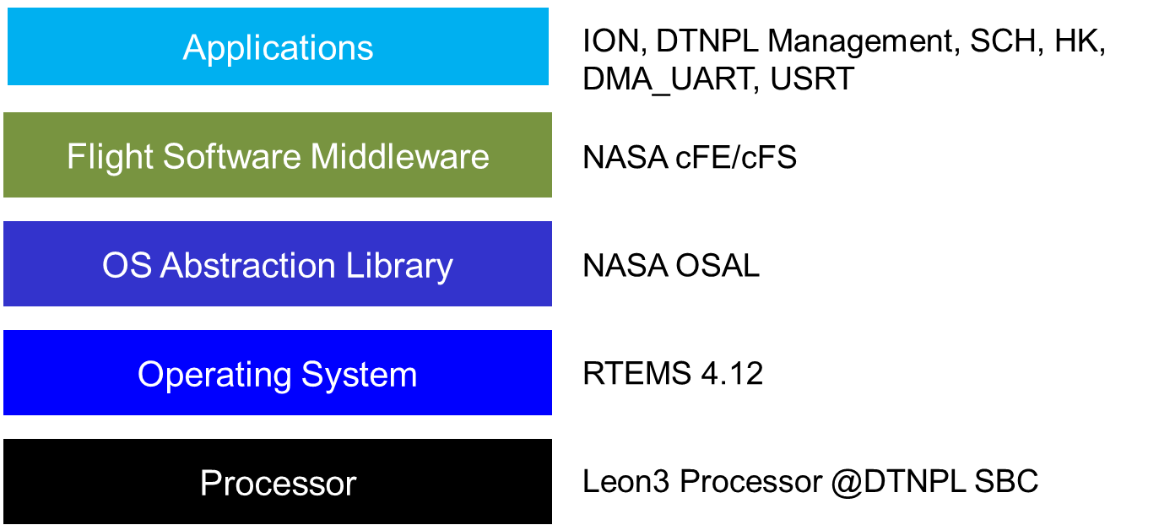
Figure 3.1 DTNPL Software Layer

All DTNPL software will be test. The target software apps are shown on below.
Figure 3.2 DTNPL Software Archetecture

ION
DTNPL Mission Processing will be tested.

DTNPL Management
Operation mode, FDIR will be tested.

SCH
Schedule management will be tested.

DMA_UART
Telecommand and Telemetry will be tested.

USRT
Datalink with PDHU will be tested.

Approach
DTN EGSE will be used to test all the software functionalities and performances. The test configuration is shown on below.
Figure 3.3 DTNPL Test Configuration

Pass/Fail Criteria
Pass/Fail Criteria will set up to test DTNPL. The criteria is divided into two parts TC verification and functional test.

TC Verification
TC verification is used to define whether the telecommand is valid or not. DTNPL EGSE can be used as an OBC and send telecommands. The DTNPL EGSE must receive expected response from DTNPL.

Functional Test
The functional test can be performed after telecommand verification is done. During this test, the task execution time will be measured.

Software Test Procedure

Test Setting
The DTNPL software test configuration is introduced on table below
Table 4-1 DTNPL Test Configuration
Name of items | Number of items | Description
DTNPL | 1 | DTNPL is a Unit Under Test(UUT).
Power Supply | 1 | This power supply is used to provide enough power to DTNPL..  The power must set to 28V.
DTNPL EGSE BOX | 1 | DTNPL EGSE BOX is directly connected to DTNPL and provide all equipment to run test..
DTNPL EGSE PC | 1 | The EGSE PC is also directly connected to DTNPL and provide user interface for software test..

This test can be set by following figure.

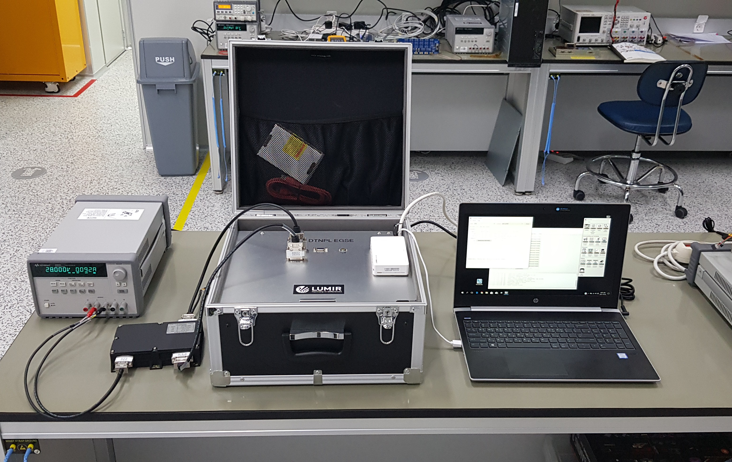
Figure 4.1 run time test result

Test Steps

Power supply
The DTNPL power supply is used to supply power to DTNPL.
- Voltage setting value: 28V
- Current limit setting value: 0.4A

DTNPL EGSE PC Set Up
- The “DTN EGSE.exe” file is clicked to enter DTNPL EGSE software test GUI

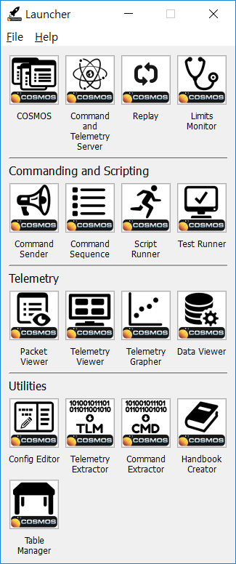
Figure 4.2 DTNPL EGSE GUI

- Command and Telemetry Server is clicked to initiate test connection between DTNPL EGSE and DTNPL
  - The green “true” indicates the connection status
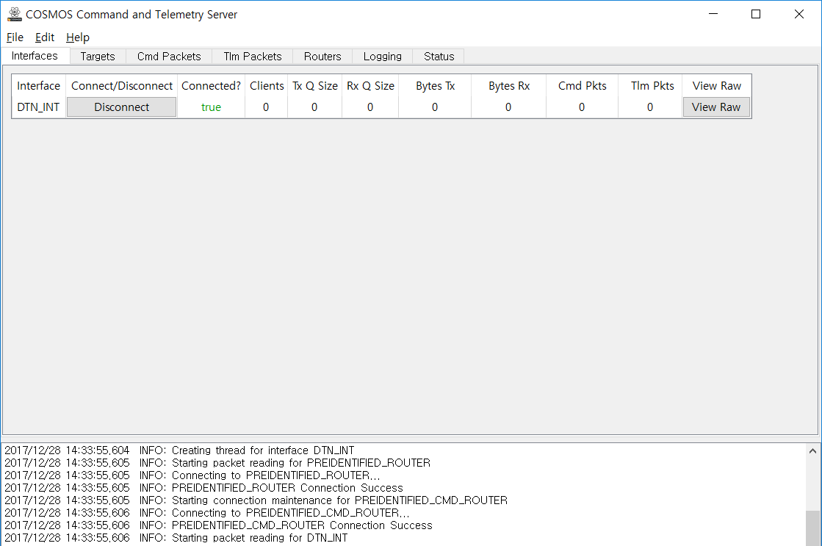
Figure 4.3 Command and Telemetry Server Window
- Telecommand can be enabled by clicking Cmd Packets icon on command and telemetry server window.
  - Command sender window will be shown.
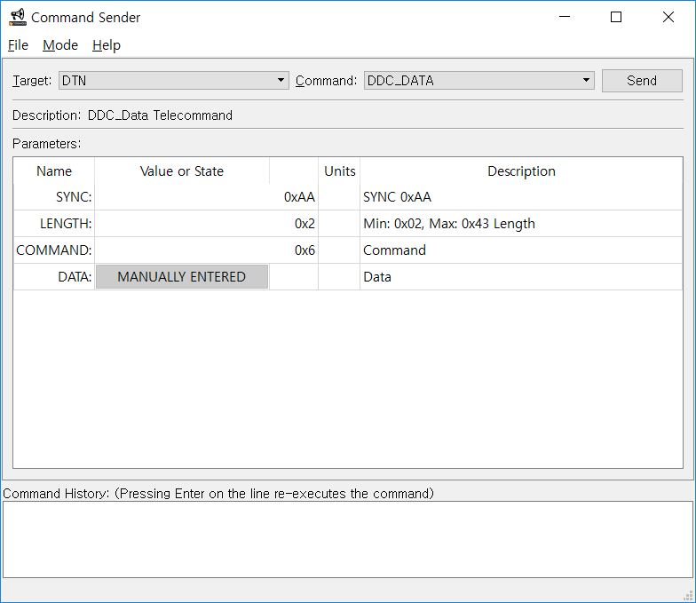
Figure 4.4 Command Sender Window

- Telemetry packets can be monitored by clicking “Tlm Packets” bar
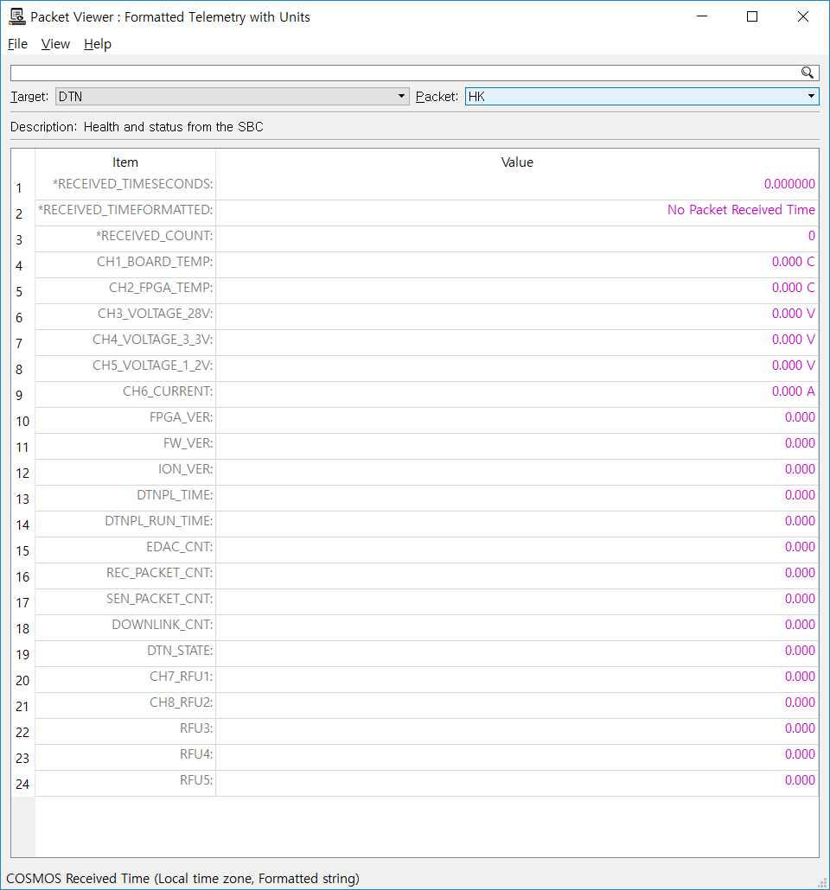
Figure 4.5 Packet Viewer Window
- The log of test process is show on “Logging” bar section.
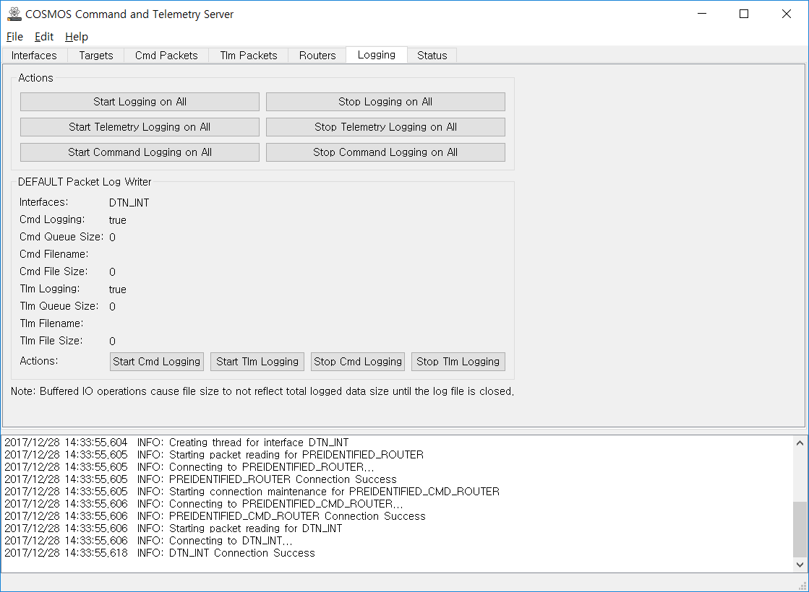
Figure 4.6 Command and Telemetry Server Window

Telecommand Test
Command sender windows shows the available TCs for test.

DDC_DATA
DDC_DATA can be selected to test and the setting values for DDC_DATA input values can be manually entered or loaded. The interface of DDC_DATA is shown on below.

Figure 4.7 TC DDC DATA

ECHO_TEST
ECHO TEST checked the reliability of communication connection between DTNPL and DTNPL EGSE. ECHO_TEST can be selected to test and the setting values for ECHO_TEST input values can be manually entered or loaded. The interface of ECHO_TEST is shown on below.

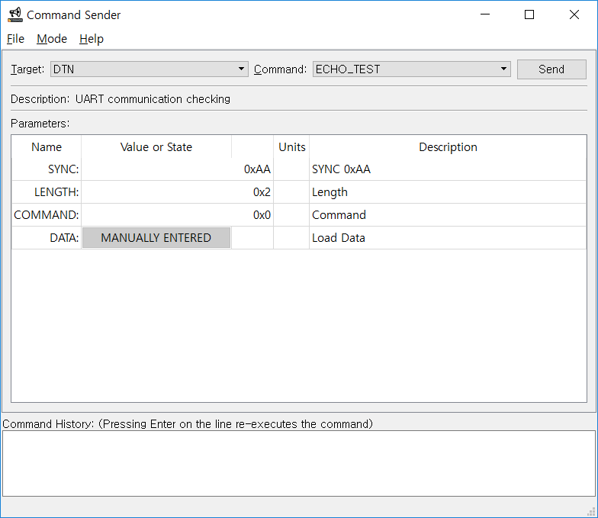
Figure 4.8 TC ECHO TEST
.

SW_INITIALIZE
The SW_INITIALIZE TC is used to initialize software and the command does not include any user inputs. The interface of software initialization TC is shown below.

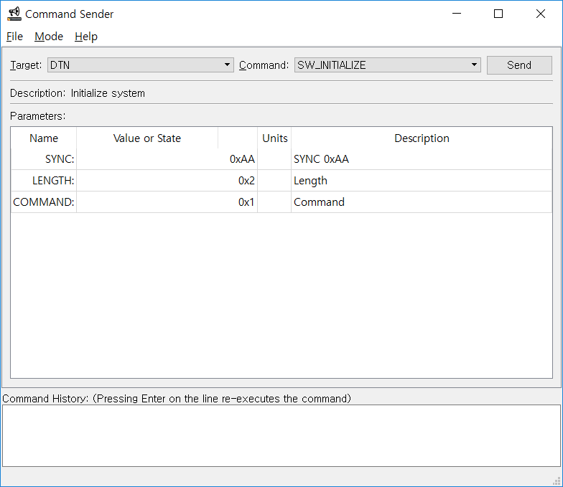
Figure 4.9 TC SW INITIALIZE

ION_START and ION_STOP
The ION START is used to start ION and ION STOP is used to stop ION operation. The interface of ION start and stop TC is shown below.

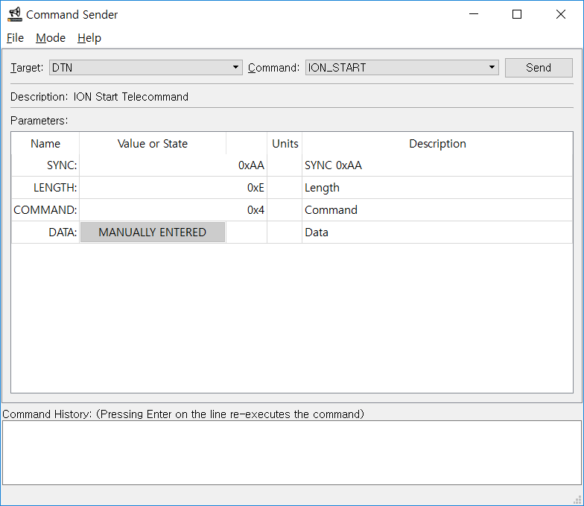  Figure 4.10 TC ION START | 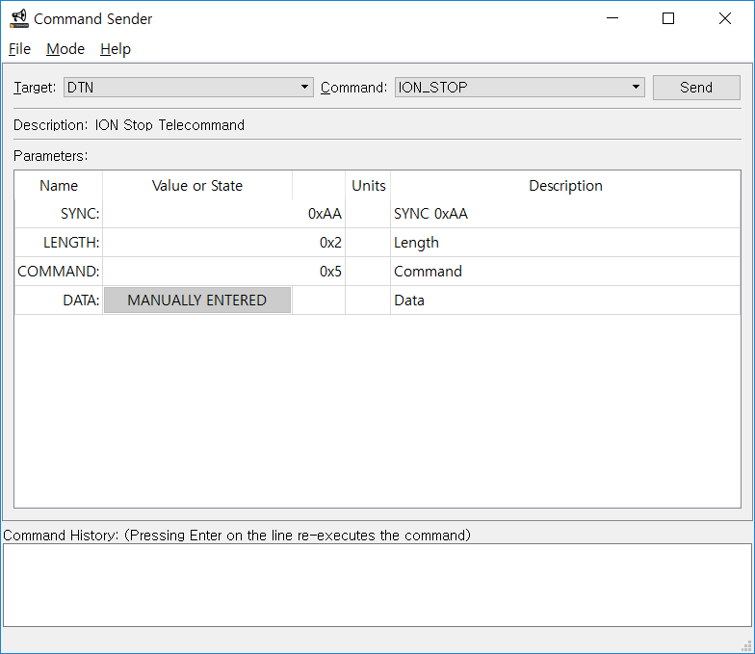  Figure 4.11 TC ION STOP

SOH_REQUEST
The SOH REQUEST TC requests state of health information. The DTNPL is designed to send state of health information every 32 seconds but state of health information can be requested anytime by this telecommand. The interface of SOH request is shown below.

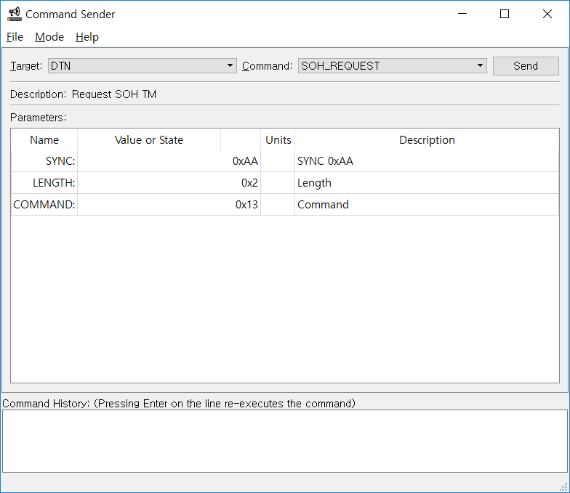
Figure 4.12 TC SOH REQUEST

TIME_SETTING
The TIME_SETTING command is used to control time in DTNPL. The week and second time can be set. The interface of Time setting is shown below.

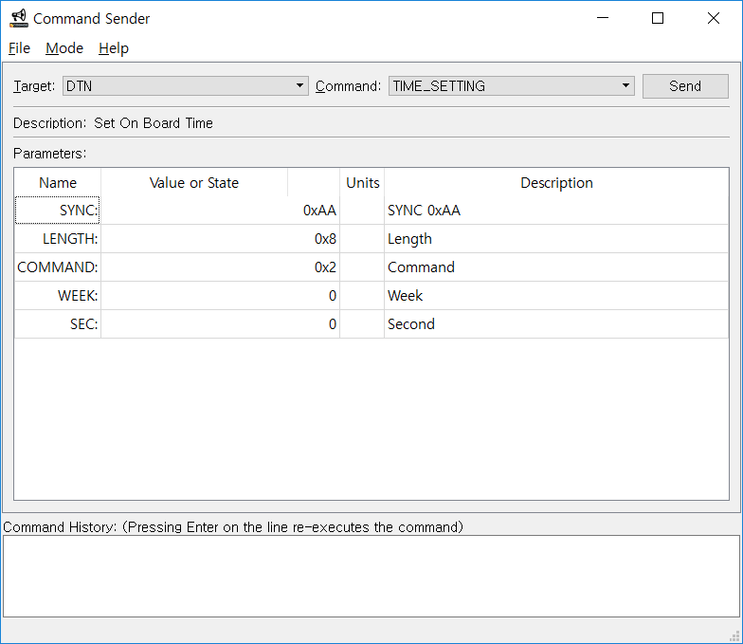
Figure 4.13 TC TIME SETTING

The summary of telecommand test list is shown below.

Table 4-1 DTNPL Command Data Structure
Type | Name | Sync | Length | Command | Data
 |  |  |  |  | Packet No | Payload Data
SBC TC | Echo test | 0xAA | 0x02 + Payload Data length | 0x00 | 0x0000 | variable
SBC TC | SW initialize | 0xAA | 0x02 | 0x01 | 0x0000 | None
SBC TC | Time setting | 0xAA | 0x08 | 0x02 | 0x0000 | OBT  - week since 2000-01-01 12:00:00 UTC (2 byte)  - octant second (4 byte)
SBC TC | SOH request | 0xAA | 0x02 | 0x13 | 0x0000 | None
SBC TC | Script (ionstart) | 0xAA | 0x0E | 0x04 | 0x0000 | Script command (12 byte)
SBC TC | Script (killm) | 0xAA | 0x09 | 0x05 | 0x0000 | Script command (7 byte)
SBC TC | DCC data | 0xAA | 0x02~0x43 | 0x06 | 0x0000 ~ 0xFFFF | DCC TC/data (0 ~ 65 byte)
SBC TC | RFU1 | 0xAA | 0x2A | 0x07 | 0x0000 | Reserved (40 byte)
SBC TC | RFU2 | 0xAA | 0x2A | 0x08 | 0x0000 | Reserved (40 byte)
SBC TC | RFU3 | 0xAA | 0x2A | 0x09 | 0x0000 | Reserved (40 byte)
SBC TC | RFU4 | 0xAA | 0x2A | 0x0A | 0x0000 | Reserved (40 byte)
SBC TC | RFU5 | 0xAA | 0x2A | 0x0B | 0x0000 | Reserved (40 byte)
SBC TM | SOH data | 0xAA | 0x3C | 0x14 | 0x0000 | SOH data (58 byte)
SBC TM | RFU1 | 0xAA | 0x06 | 0x15 | 0x0000 | Reserved (4 byte)
SBC TM | RFU2 | 0xAA | 0x06 | 0x16 | 0x0000 | Reserved (4 byte)
SBC TM | RFU3 | 0xAA | 0x06 | 0x17 | 0x0000 | Reserved (4 byte)
SBC TM | RFU4 | 0xAA | 0x06 | 0x18 | 0x0000 | Reserved (4 byte)
SBC TM | RFU5 | 0xAA | 0x06 | 0x19 | 0x0000 | Reserved (4 byte)

Table 4-2 DTNPL Command Data Structure
Type | TC name | Description
SBC | Echo test | UART communication checking
SBC | SW initialize | Initialize system
SBC | Time setting | Set On Board Time
SBC | SOH request | Request SOH TM
SBC | RFU_1 | Reserved for future use
SBC | RFU_2 | Reserved for future use
SBC | RFU_3 | Reserved for future use
SBC | RFU_4 | Reserved for future use
SBC | RFU_5 | Reserved for future use
DTN | Script (ion start) | ION Start
DTN | Script (killm) | Close all process
DTN | DCC data | AMS TC / CFDP file data transfer

Telemetry Test
Telemetry can be transmitted every 32 seconds since DTNPL is operating or by a SOH request command. The telemetry interface is shown on below.
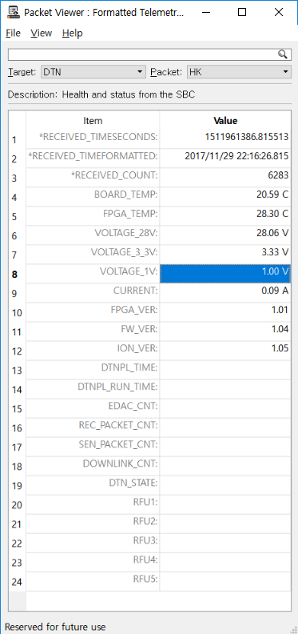
Figure 4.14 SOH Telemetry

The detail of tested telemetry is shown below.
Table 4-2 DTNPL Telemetry Lists
Type | TM name | Description | Size  (byte) | Start time  (sec.) | Update interval | Transmit interval to FSW
SBC | SOH Data | temp_board (Board temperature) | 4 | Auto count after DTNPL power ON | <1 sec. | After receiving SOH request (32 sec).
SBC | SOH Data | temp_fpga (FPGA temperature) | 4 | Auto count after DTNPL power ON | <1 sec. | After receiving SOH request (32 sec).
SBC | SOH Data | volt_28 (28.0V input voltage level) | 2 | Auto count after DTNPL power ON | <1 sec. | After receiving SOH request (32 sec).
SBC | SOH Data | volt_3.3 (3.3V voltage level) | 2 | Auto count after DTNPL power ON | <1 sec. | After receiving SOH request (32 sec).
SBC | SOH Data | volt_1.0 (1.0V voltage level) | 2 | Auto count after DTNPL power ON | <1 sec. | After receiving SOH request (32 sec).
SBC | SOH Data | curr_28 (28.0V input current level) | 2 | Auto count after DTNPL power ON | <1 sec. | After receiving SOH request (32 sec).
SBC | SOH Data | time (Current DTNPL time) | 6 | Auto count after DTNPL power ON | 1 sec. | After receiving SOH request (32 sec).
SBC | SOH Data | run_time (Time(second) count after DTNPL power on) | 4 | Auto count after DTNPL power ON | 1 sec. | After receiving SOH request (32 sec).
SBC | SOH Data | fpga_ver (SBC FPGA version) | 4 | Auto count after DTNPL power ON | Fixed | After receiving SOH request (32 sec).
SBC | SOH Data | fw_ver (SBC firmware version) | 4 | Auto count after DTNPL power ON | Fixed | After receiving SOH request (32 sec).
SBC | SOH Data | edac (EDAC count) | 4 | Auto count after DTNPL power ON | Event occurred | After receiving SOH request (32 sec).
SBC | SOH Data | tmtc_rx_pkt_cnt (OBC→DTNPL received packet count) | 4 | Auto count after DTNPL power ON | When packet received | After receiving SOH request (32 sec).
SBC | SOH Data | tmtc_tx_pkt_cnt (DTNPL→OBC send packet count) | 4 | Auto count after DTNPL power ON | When packet sent | After receiving SOH request (32 sec).
SBC | SOH Data | downlink_pkt_cnt (DTNPL→PDHU send packet count) | 4 | Auto count after DTNPL power ON | When packet sent | After receiving SOH request (32 sec).
SBC | SOH Data | dtn_state (ION start/stop state) | 4 | Auto count after DTNPL power ON | 1 sec. | After receiving SOH request (32 sec).
SBC | SOH Data | ion_ver (ION version) | 4 | Auto count after DTNPL power ON | Fixed | After receiving SOH request (32 sec).
SBC | RFU_1 | Reserved for future use | 4 | -
SBC | RFU_2 | Reserved for future use | 4 | -
SBC | RFU_3 | Reserved for future use | 4 | -
SBC | RFU_4 | Reserved for future use | 4 | -
SBC | RFU_5 | Reserved for future use | 4 | -
DTN |  |  | - | -

